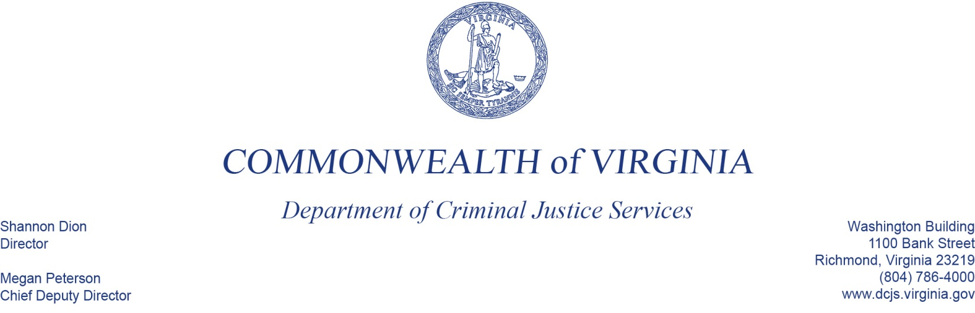
DCJS Compliance Monitoring:
Enhanced Programmatic Desk Review
Hanover Safe Place 20-A3582VP18 20-K2212SP19 20-X9411VA19
June 29, 2020 at 10:00 AM
Conference Line: 1-866-845-1266
Conference Code (participants): 92635532

Purpose:
The Department of Criminal Justice Services (DCJS) Grant Monitoring Plan ensures that sub-grantees are in compliance with all grant conditions. The department develops a risk-based monitoring plan, conducts fiscal and programmatic monitoring on all sub-grantees, and enhanced monitoring of sub-grantees determined to be medium and high risk.

Definitions:
Enhanced Financial Desk Review – In-depth monitoring performed remotely from the grantor site. Financial monitors assess the financial integrity and accountability of their grants and grantees using virtual and telephone communication methods for interacting with grantees and reviewing grant general ledgers and supporting documents.

DCJS Staff:
Tierra Smith, Victims Services Grants & V-STOP Coordination Specialist- tierra.smith@dcjs.virginia.gov

AGENDA

10:00 AM Entrance Conference (facilitated by Tierra Smith)

10:10 AM Overview of Risk Assessment (facilitated by Tierra Smith)

10:15 AM Program Update (facilitated by Project Director)

10:30 AM Staff Interviews
- Stacie Francis, Project Director (10:30-11:00)
- Finance Officer or Finance Personnel (11:10-11:40)
- Sheree Hedrick, Executive Director (12:00-12:30)
- Jessica Bell, Counselor (12:40-1:10)
- Jane Yancey, Court Advocate (1:20-1:50)
- Emily Agee, Children’s Services (2:00-2:30)
- Itzel Patino, Services Coordinator (2:40-3:10)

3:15 PM Conclusion (facilitated by Tierra Smith with Project Director)
- Preliminary Findings
- Technical Assistance Needs
- Next Steps

